# Overview

This document contains the necessary information to build the Interact Switch, a large customizable switch with a low activation force.

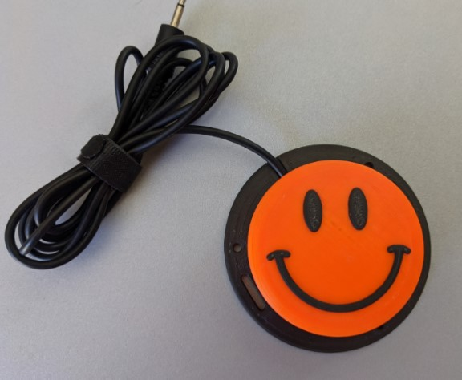

Contents

Overview 1

Maker Checklist 3

Maker To Do List 3

Items to Give to User 3

Attribution 3

Tool List 4

Tools / Equipment 4

Supplies 4

Personal Protective Equipment (PPE) 4

Customization Guide 5

3D Printing Guide 8

3D Printing Summary 8

3D Printing Settings 8

Post-Processing 9

Examples of Quality Prints 9

Building the Interact Switch 10

Required Components 10

Required Tools and Supplies 10

Required Personal Protective Equipment (PPE) 10

Assembly Steps 11

Testing 15

Troubleshooting 15

# Maker Checklist

This list provides an overview of the steps required to build and deliver the Interact Switch.

## Maker To Do List

* Read through the Maker Guide to become familiar with required components, tools, supplies, safety gear, and overall assembly steps.
* Talk to the User about customization options
  + What colour(s) would they like the topper and/or topper pattern to be printed in?
  + Which topper would they like to have? There are a variety of toppers available with different patterns and textures.
  + How would they like to receive the “User Guide”? (PDF or physical copy)
* Order hardware components
* Gather tools, supplies, and safety equipment.
* Assemble the device
* Test the Interact Switch

## Items to Give to User

* Interact Switch
* User Guide

## Attribution

The [Interact Switch](https://github.com/mwturvey/InteractSwitch/tree/master) design by [Mike Turvey](https://github.com/mwturvey) is used under [CC-BY 4.0](https://creativecommons.org/licenses/by/4.0/). Instructions adapted from [Original Interact Switch Assembly Instructions](https://docs.google.com/document/d/1uWRKXmApZUaSo1I0oyyFrAfncziYsd2_8ai8dunogJs/edit?usp=sharing) by [Mike Turvey](https://github.com/mwturvey), used under [CC-BY 4.0.](https://creativecommons.org/licenses/by/4.0/)

Due to changes made to make the switch compatible with the #4 sheet metal screws, the Base and Switch holder are no longer compatible with the original parts.

# Tool List

## Tools / Equipment

|  |  |  |  |
| --- | --- | --- | --- |
| Tool ID | Description | Required / Recommended | Notes |
| T01 | Wire Strippers | Required | Stripping insulation from the cable |
| T02 | Soldering Iron | Required | Soldering the Cable to the switch |
| T03 | Phillips Screwdriver | Required | Attaching the base to the top |

## Supplies

|  |  |  |  |  |
| --- | --- | --- | --- | --- |
| Supplies ID | Description | Quantity | | Notes |
| S01 | Solder | Roughly 1 inch | To attach the mono cable to the button | |

## Personal Protective Equipment (PPE)

|  |  |  |
| --- | --- | --- |
| PPE ID | Description | Notes |
| P01 | Safety Glasses | To keep flying debris out of your eyes |

# Customization Guide

The device can be printed in the user’s desired colour.

There are over 12 different button caps available in the GitHub repository, and some projects such as the Open Playback Recorder have custom Interact Switch caps that match buttons on the device.

When printing the textured button caps, a filament change can be done to print the textured part of the cap in a different colour from the main body, increasing contrast. This can also be done automatically on printers that support multi-material printing.

The plain, ‘default’ button topper can be seen below, and the other options included in the Interact Switch Repository are listed in the table below.

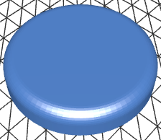

|  |  |  |
| --- | --- | --- |
| **Arrow** | **Circle** | **Dome** |
| 3D render of arrow Interact Switch cap | 3D render of circle Interact Switch cap | 3D render of domed Interact Switch cap |
| **Dots Circles** | **Dots Wide** | **Lines** |
| 3D render of Interact Switch cap covered in small dots | 3D render of Interact Switch cap covered in medium dots | 3D render of Interact Switch cap covered in fine lines |
| **Lines Very Wide** | **Lines Wide** | **Octagon** |
| 3D render of Interact Switch cap covered in heavy lines | 3D render of Interact Switch cap covered in medium lines | 3D render of Interact Switch cap with an octagon on top |
| **Rings** | **Rings Wide** | **Smile** |
| 3D render of Interact Switch cap covered in fine concentric circles | 3D render of Interact Switch cap covered in large concentric circles | 3D render of Interact Switch cap with a smiley face on top |

# 3D Printing Guide

The device was originally printed on a Bambu P1S using Bambu Studio using the default profile.

## 3D Printing Summary

|  |  |
| --- | --- |
| **Metrics** | **Single Unit** |
| Total Print Time (hour min) | 1h8min |
| Total Number of Components | 4 |
| Typical Total Mass (g) | 35 |
| Typical Number of Print Setups | 2 |

## 3D Printing Settings

Note that the 3D printing material should be assumed to be PLA unless otherwise noted in the table below.

|  |  |  |  |  |  |  |  |
| --- | --- | --- | --- | --- | --- | --- | --- |
| **Print File Name** | **Qty** | **Total Print Time (hr:min)** | **Mass (g)** | **Infill (%)** | **Suppor**  **(Y/N)** | **Layer Height/ Nozzle Diameter(mm)** | **Notes** |
| Interact_Switch_Base.stl | 1 | 0:32 | 17 | 20 | N | 0.2/0.4 |  |
| Interact_Switch_Cap_Plain.stl | 1 | 0:25 | 14 | 20 | N | 0.2/0.4 | Default cap; others are available |
| Interact_Switch_Holder.stl | 1 | 0:09 | 3 | 20 | N | 0.2/0.4 |  |
| Interact_Switch_Insert_0.6mm.stl | 1 | 0:02 | 1 | 20 | N | 0.2/0.4 | Inserts from 0.2mm to 1.5mm are available, 0.6 works for most printers |

Depending on the tolerances of your printer, you may have to print a different switch insert than the 0.6mm insert. The insert is the part that makes the cap press the switch in the base, and depending on the tolerances of your printer, this distance might be too close or too far for the 0.6mm insert. The repository includes inserts from 0.2 to 1.5mm and it may take a few tries to find the right one that works for your printer.

## Post-Processing

Inspect the 3D printed parts for any printing defects, sharp edges, or burrs. Sharp edges and burrs can be removed with sanding or deburring tools.

## Examples of Quality Prints

Compare your 3D prints to the images here. If there are significant differences, you may need to reprint the part.

|  |  |  |
| --- | --- | --- |
| Interact Switch | | |
| Interact_Switch_Base.stl | Interact_Switch_Cap_Plain.stl | Interact_Switch_Holder.stl |
| *A blue plastic 3D printed switch base on a black surface.* | A green circular plastic 3D printed switch cap on a black surface. | Black U shaped 3D printed Button Cap Holder |
| Interact_Switch_Insert_0.6mm.stl |  |  |
| Red Y shaped 3D printed Button Cap Insert |  |  |

## Building the Interact Switch

### Required Components

|  |  |  |  |  |  |  |  |  |  |  |  |  |  |  |
| --- | --- | --- | --- | --- | --- | --- | --- | --- | --- | --- | --- | --- | --- | --- |
| Interact Switch | | | | | | | | | | | | | | |
| A01 | | Switch Base | | QTY: 1 | A02 | | Button Cap Holder | | QTY: 1 | A03 | | Button Cap Insert | | QTY: 1 |
| *A blue plastic 3D printed switch base on a black surface.* | | | | | Black U shaped 3D printed Button Cap Holder | | | | | **Red Y shaped 3D printed Button Cap Insert** | | | | |
| A04 | Button Cap | | QTY: 1 | | A05 | Limit Switch | | QTY: 1 | | A06 | Mono Cable | | QTY: 1 | |
| A green circular plastic 3D printed switch cap on a black surface. | | | | | Close up picture of a black rectangular button with 3 silver leads. | | | | | A black mono cable, wound up. One end had a 3.5 mm mono jack and on the other end the wires are stripped. | | | | |
| A07 | #4 Sheet Metal Screw | | QTY: 3 | |  |  | |  | |  |  | |  | |
| Graphic of a self threading Philips screw. | | | | |  | | | | |  | | | | |

### Required Tools and Supplies

* Wire Strippers
* Soldering Iron
* Screwdriver

### Required Personal Protective Equipment (PPE)

* Safety Glasses

### Assembly Steps

#### Step 1: Prep Cable

Cut off and discard one of the plugs from the mono audio cable.

Use the wire strippers to carefully remove about 15 mm of the outer insulation from the end.

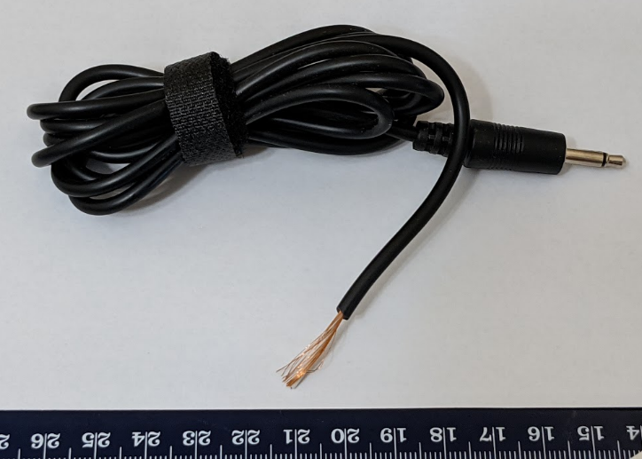

#### Step 2: Prep Cable Wires

Twist the copper strands together into a single wire.

Use the wire strippers to remove roughly 5 mm of insulation from the other wire.

*(Note: Your cable may differ. If there are two wires with insulation, strip 5 mm from the end of each wire.)*

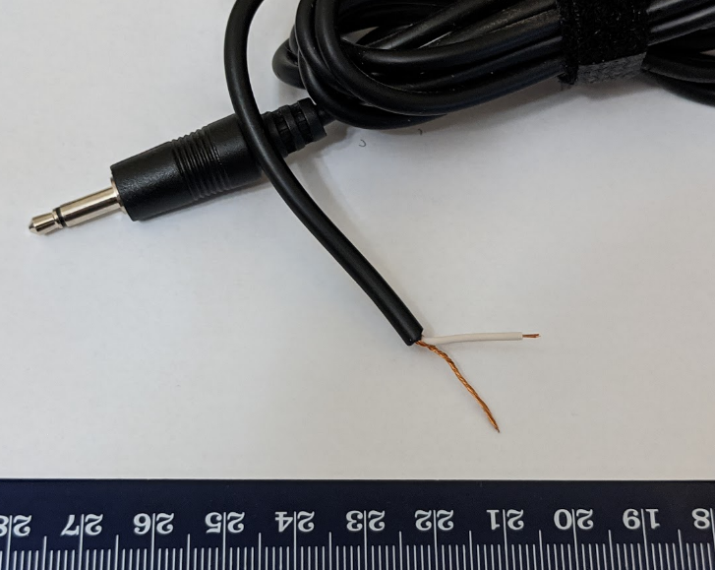

#### Step 3: Thread Cable into Switch Base

Thread the cable through the hole in the Switch Base. You will not be able to do this after you solder the limit switch onto the wire.

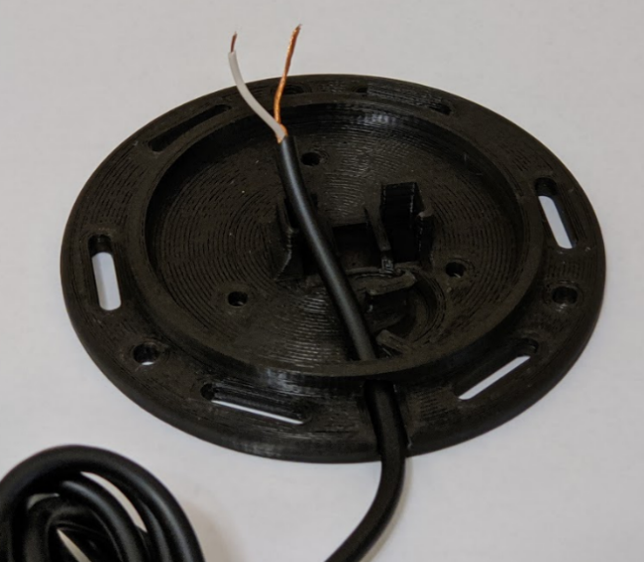

#### Step 4: Solder Wires to Switch

Solder the wires into the switch in the position shown below.

**Note:** Solder the two leads closest to the button on the switch.

**Test:** plug your switch into a switch activated device and push the button on the limit switch

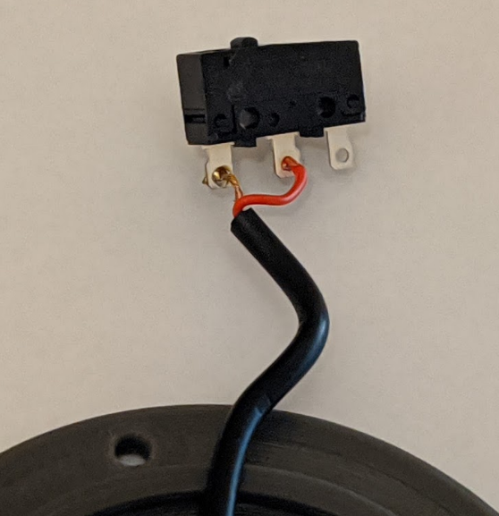

#### Step 5: Position Switch in Base

Place the limit switch into the Switch Base as shown.

For the orientation of the switch, when the cable is coming towards you, the button on the limit switch should be offset to the left. Make sure that no wires are stuck underneath, preventing the limit switch from going all the way down.

Push the cable in the slot as shown in the picture.

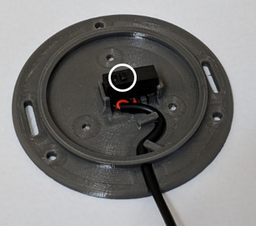

#### Step 6: Assemble Button Cap

Turn the Button Cap over and insert the Button Cap Insert. If you’re unsure which size to use, try starting with 0.6 mm. The lines on the button insert should be facing up, with the print surface facing down towards the cap. The raised section where all three legs on the insert join should be visible.

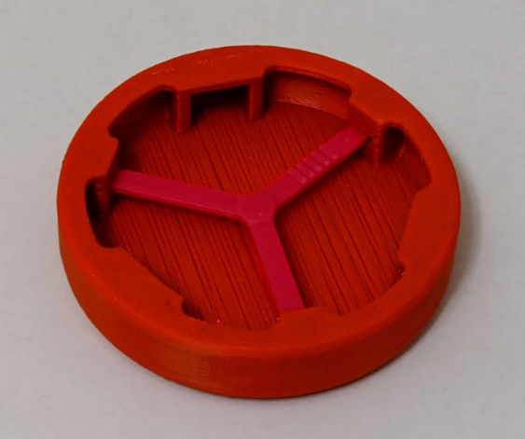 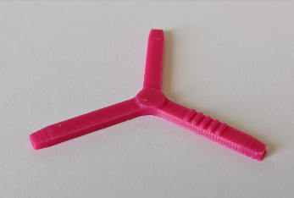

#### Step 7: Finalize Button Cap Assembly

Insert the Button Cap Holder into the Button Cap Assembly. The orientation of the “open” side doesn’t matter.

**Note:** for smoother switch action, sand the edges of the Button Cap Holder where it rubs on the switch.

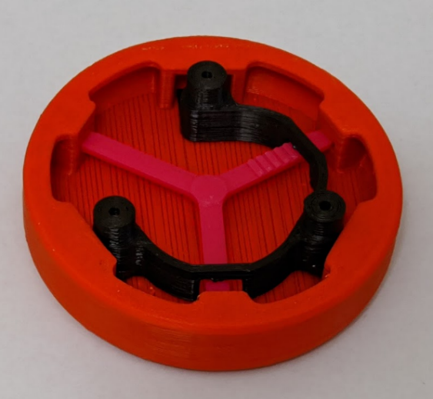

#### Step 8: Assemble Switch

Align the three posts of the Switch Cap Holder to the three holes in the Switch Base. Secure the Switch Cap Holder to the Switch Base using three screws.

**Note:** Be careful not to over tighten the screws. Tighten them until you notice the resistance increases and the Switch Cap Holder is firmly against the Switch Base.

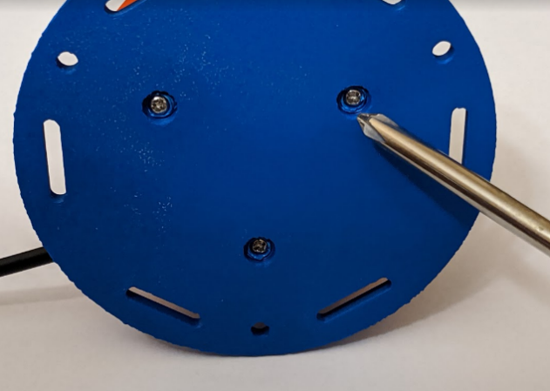

# Testing

The last thing to do is test your switch. If this is your first switch, you’ll likely need to test it out and figure out the best size of Switch Cap Insert to use.

The first thing to do to test a switch is to push it a lot. Tap it everywhere, repeatedly. Every time you push it, you should hear it click down and click as it goes back up. It should never stick. If you wiggle the top, it should move some, but it shouldn’t feel like it’s rattling around. Next, plug the switch into a switch activated device and make sure that it works.

# Troubleshooting

|  |  |
| --- | --- |
| **Problem** | **Solution** |
| The switch cap is too loose and rattles around easily. | Use a larger/ thicker Switch Cap Insert. |
| Switch doesn’t make any noise when pushed. | Use a smaller/ thinner Switch Cap Insert.  An insert that is too big can cause the limit switch to be always depressed.  When this is the case, you’ll often hear the limit switch “click” closed when you’re screwing everything together, but it won’t ever click open. |
| Switch sticks/ doesn’t always go back up. | Use a smaller/ thinner Switch Cap Insert.  You may likely need just one size thinner. |
| Switch makes clicking noise, but the switch activated device isn’t activating | * Test the switch activated device with a switch known to work, just to make sure it’s working fine. * Check that the plug is firmly plugged into the device * The solder connection may be bad and need to be re-soldered. * There may be an internal break in the wire, and you will need to replace it.  This is a particularly common failure point for an older switch. |